CHAPTER ONE
INTRODUCTION TO WIRELESS AUDIO AMPLIFIER
1.1 BACKGROUND
The term amplifier refers to any device that increases the amplitude of a signal usually measured in voltage or current. This versatile device s used in a variety of different electronic applications. Especially in audio technology, a wide range of appliers can be produced based on product specifications (1e. Power, voltage, current). Currently, there are many types of audio amplifiers available for consumers. [1]
Sound signal amplification is used for instruments, such as the guitar or the bass. They are also used commonly in-home theater systems and with stereo speakers. The basic design behind all of these amplifiers s derived from the simplest concepts of circuit design.
for our project, we set out to constructs an audio amplifier. The inputs of our circuit were stereo signals from a portable music player. Although we used a low-power speaker, we needed to achieve approximately three times gain over the entre circuit. In addition, the amplifier had to be produced at a known cost with available materials. Before building the actual amplifier, we realized that we had to construct, simulate, and test the circuit. Each step was necessary to understand the concepts involved in amplification. [2]
AN AUDIO POWER AMPLIFIER (or power amp) is an electronic amplifier that amplifies low-power electronic audio signals such as the signal from radio receiver or electric guitar pickup to a level that is high enough for driving loudspeakers or headphones. Audio power amplifiers are found in all manner of sound systems including sound reinforcement, public address and home audio systems and musical instrument amplifiers like guitar amplifiers. It is the final electronic stage in a typical audio playback chain before the signal is sent to the loudspeakers. [3]
BLUETOOTH
As a technology, Bluetooth originated in [4] Sweden in the late 1990s. Its original purpose was to eliminate the need for unnecessary cable connections between devices from different manufacturers.
For example, if you have a smartphone from apple and a speaker from job or Bose, it could be difficult to get an audio signal from one to the other due to the fact that the two devices both have rather proprietary connections.
However, Bluetooth allows devices to connect to one another with short-range radio frequencies that alternate several hundred times a second. This also lends itself to security, making Bluetooth connection a very secure way for data to be transferred.
Bluetooth wireless technology (bwt) has nearly unlimited potential, especially in the internet of things, and is currently also used in smart speakers, smart home implementations, and several other devices.
WIRELESS BLUETOOTH AMPLIFIER
Understanding technology is a complicated uphill battle. Because there’s never any shortage of products brought to market, trying to stay on top of them can seem incredibly daunting. The Bluetooth headphone amp is one such product. Because it hasn’t been around for long, it’s a good idea to start by defining what it is.
1.2 STATEMENT OF PROBLEM
- It has a tendency to become noisy with age especially in moist climate.
- The voltage gain reduces at low as well as high frequencies.
- It provides poor impedance matching and hence it cannot be used as a final stage of an amplifier.
Advantages:
- It has wide frequency response and large bandwidth.
- It is most convenient and least expensive amplifier.
- It provides high audio fidelity.
- It has low amplitude distortion.
- It provides low frequency distortion.

1.3 AIMS AND OBJECTIVES
Aims and objectives
- To construct cost-effective high-power audio amplifier.
- To control the system via wireless Bluetooth module.
The overall objective of this project is to construct wireless audio amplifier whilst ensuring a high sound quality at all input frequencies and volume settings.
The housing for the circuitry and speakers must also be considered, it should be
Strong enough to withstand being moved about and sturdy as to ensure that it doesn't rattle when it is playing music. It should appear professionally made and with an interesting and unique design. It should be simple to use allowing it to be enjoyed by all consumers, of all ages, as well as having a high-quality sound output with minimal static, especially at the more common ranges of frequencies. The speaker system must have a wide range in volume, which must be easily controlled. Portability is not an issue as this is not to be designed as a portable amplifier, rather A semi-permanent loudspeaker system. The product is to have one speaker set up In stereo, with the input to be provided by an mp3 device. The one speaker will Have an internal resistance of 8 ohms each, with each wired to either the left or Right feed of the audio from the mp3 device jack. The amplifier will have a gain of 20db. The volume controls will be an analogue system using a potentiometer connecting both of the two speaker systems together to ensure consistency Throughout the listening experience. The system will be powered by one 12-volt battery which will be easily accessible for ease of access. To ensure that the power source does not drain over time, a switch will be connected to enable the whole system to be turned on and off. The housing for the speakers and for the circuitry will be of a unique design whilst still enabling for practicality in terms of connecting the mp3 device, volume control and powering the amplifier system on and off.
Applications:
- It is used in the initial stages of public address (pa) amplifier systems.
- It is used in stereo amplifier.
- It is widely used as a voltage’s amplifier.
- It is used in radio and card reader

1.4 METHODOLOGY:
The circuit is constructed by using tda2822 (ic), and two major component which consist of speaker and battery. Where pin one is connected to a 220uf capacitor together with a speaker to the ground and produce output. And pin two +vcc which is the power supply to the circuit. And pin four is move directly to the ground and pin five 10uf is directly to the ground together with 1k-15k resistor that come from pin six+. The 15k resistor are connected to the ceramic capacitor100uf also is connected with 10k variable resistor that move to the ground. The pin seven+ 15k resistor is connected where ceramic capacitor100uf are attach to it with variable resistor 10k is connected to it and directly move to the ground where 1k resistor is connected to the 15k that comes from pin seven (7) and move to the ground. Where left and right of variable resistor are connected together. The last pin which is pin eight (8) is connected with 10uf capacitor to ground.
1.5 SIGNIFICANCE OF THE PROJECT
Significance of using audio power amplifiers
Let us discuss here in detail about power amplifiers but for that we need to know what the term amplifier. It is used to take an input signal and increase its amplitude. These amplifiers find use in all major kinds of electronic devices which are designed to perform many functions. There are various types of amplifiers available in the market and each one has its own specific utility. Take example of a radio transmitter which uses an rf amplifier which is designed to amplify a signal to drive an antenna. The power amplifiers are designed to drive loudspeakers.
In simple terms let us make you understand the purpose of using power amplifier; it takes signal from a source device which is then used at the transmitter end to drive a loudspeaker receiver such as those found here. It simply increases the amplitude of the input signal and drives it to the output end without any signal power l oss.
However, the signal received at the receiver end of all audio amplifiers contain many unwanted components that were not present at the transmission end which is called as the distortion. There are many types of distortion let us not go deep into that. One type of distortion creates noise that is heard by all of us at the background which does not allow the music to be played.
1.6 SCOPE OF THE PROJECT
Scope of the report
An audio amplifier is an electronic amplifier, which amplifies low-power electronic audio signals, such as the signal from a radio receiver to a level that is high enough for loudspeakers or headphones.
1.7 REPORT OUTLINE
This section describes the introduction part of our project. It introduce basic concept of audio amplifier wireless performance using a minimum amount of power of bandwidth. The second chapter explain literature review. It include background history of audio amplifier previous studies and theories used to guide during our project. The third chapter discourse the constructions and analysis of the body of the project. Its explain block diagram, calculation component value, schematic diagrams and result. The fourth chapter explain the value test carries out the result in tabular format and the discussion from the result. Finally the project also include conclusion, limitation, recommendation, references. [5]

CHAPTER TWO:
LITERATURE REVIEW

The previous tutorials, the amplifier circuits to boost audio from a single channel were designed. Over the last decade, there is growth in the audiophile. This has brought a revolution in the music industry. Now, people like to hear the high-resolution surround music just like a 3d video. A surround sound system is designed to create a sound field like the sound is coming from back, front, left and right sides. It can also create the sound above the listener. The surround sound system is used in cinemas and drama theaters to give a realistic feeling to the audience. An alternative to the surround sound system is stereo audio system. [6].
There are basically two sound systems –
1) mono sound system- the mono system produces a mono-natural sound which comes from a single channel and is reproduced by a single speaker. Though a greater number of speakers can be added to play the same audio channel but a copy of the same sound will be played on all the speakers in such system.
2) stereo sound system – in the stereo sound system, the stereophonic sound, also known as stereo sound, can be heard by different channels using more than one speaker. Generally, by the stereo system, it is meant that there are two independent audio channels which are reproduced by two or more speakers separately. Such a system is widely used in head phones. For designing a stereo sound system there are two channels required as well as the audio source is required which can provide the stereo sound. So that the audio signal from two audio channels could be obtained and the sound can be reproduced at different speakers. [7]

For a stereo sound system, the same number of amplifiers are required as the number of audio channels. In this tutorial, a stereo power audio amplifier will be designed using tda2822 ic. Tda2822 is a dual power amplifier having two independent amplifier circuits on the same chip. The ic can be used as bridge or stereo audio amplifier.[8]
In the circuit designed in this tutorial, the ic is used as stereo power amplifier to boost to audio channels and output audio to two separate speakers.
In the introductory article of this series, various design parameters of the audio amplifier circuits were discussed like gain, volume, skew rate, linearity, bandwidth, clipping effect, stability, efficiency, snr, output power, thd and loop grounding. This amplifier circuit will be designed considering the following design parameters –
Gain (voltage) – 39 db
Bandwidth – 20 hz to 20 khz
Output power – 1 watt
The amplifier will be designed to supply audio to two speakers having an impedance of 8 ohms. The circuit will have the following additional features –
– no clipping effects
– stereo output
The designing of the circuit will be followed by testing of the circuit for the verification of the intended design factors
Component required

CHAPTER THREE
3.1 SYSTEM'S DESCRIPTION
The amplifier circuit is built by assembling the following components together –

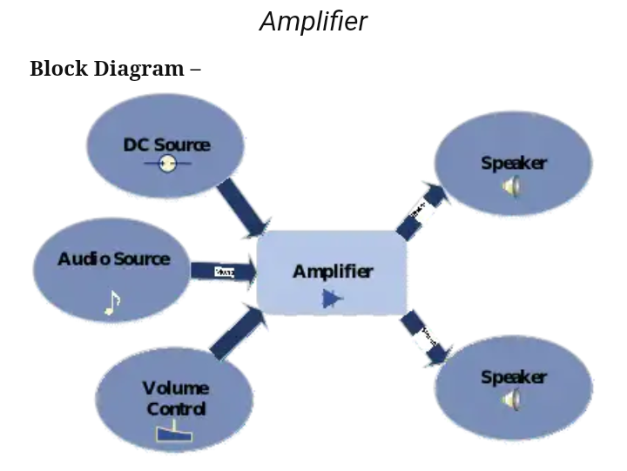
Bluetooth
Circuit connections –

1) DC SOURCE – the amplifier circuit is powered by a battery of 3.7v and 1.5 a rating. The power supply is passed through a capacitor (shown as c3 in the circuit diagram) of 10uf. This is a filtering capacitor to remove any unwanted ripples from the power source.
2) AUDIO SOURCE – the audio input is provided from a smart phone. For receiving audio from the smart phone, an audio jack of 3.5 mm is plugged into the phone. The 3.5 mm audio jack has three wires – one for ground and two wires for left and right channel. As the amplifier is designed for both channels, both of the channel wires will be connected to the amplifier as audio input. Both the channels are used for applying the stereo sound to the input of the amplifier. The ground wire of the jack will be connected to the common ground of the circuit. Generally, the audio signals on such two channels are out of phase by 180 degrees making the system a balanced audio system. [9].

3) SPEAKER
A speaker is a device that use to convert electrical signal or electro- magnetic waves into sound energy
4)AMPLIFIER
An amplifier is an electronics device which use to boost the level of alectric signal from one stage to another
5) VOLUME CARDS are electrical programmable devices that use to control/ regulate the volume of a system

3.2 FUNCTIONAL COMPONENTS
A resistor is a passive two-terminal electrical component that implements electrical resistance as a circuit element. In electronic circuits, resistors are used to reduce current flow, adjust signal levels, to divide voltages, bias active elements, and terminate transmission lines, among other uses. High-power resistors that can dissipate many watts of electrical power as heat, may be used as part of motor controls, in power distribution systems, or as test loads for generators. Fixed resistors have resistances that only change slightly with temperature, time or operating voltage. Variable resistors can be used to adjust circuit elements (such as a volume control or a lamp dimmer), or as sensing devices for heat, light, humidity, force, or chemical activity. Sejdic, E. and Mickle, M. (2015).

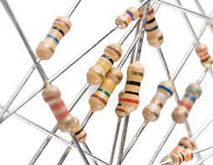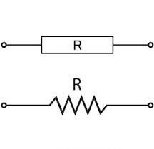
A CAPACITOR is a device that stores electrical energy in an electric field. It is a passive electronic component with two terminals.
The effect of a capacitor is known as capacitance. While some capacitance exists between any two electrical conductors in proximity in a circuit, a capacitor is a component designed to add capacitance to a circuit. The capacitor was originally known as a condenser or compensator.[1] this name and its cognates are still widely used in many languages, but rarely in english, one notable exception being condenser microphones, also called capacitor microphones.
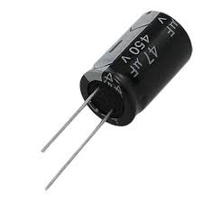
Though capacitors are tiny, they provide various benefits in electronic circuits.
They store energy directly onto the plates, which makes the charging/discharging process much faster.
They are effective in filtering out unwanted frequencies.
Capacitors can handle power loss efficiently and make power production more economical.
They are less sensitive to temperature.
Capacitors discharge current almost instantaneously.
Capacitors are preferred for ac applications.
They are capable of handling high voltage applications, and are therefore suitable for high frequency use cases.
Capacitors have a long-life cycle of almost ten to 15 years.

CERAMIC CAPACITORS: these capacitors have no polarity and a fixed capacitance. They use a ceramic substance as the dielectric material. There are two types of ceramic capacitors that are commonly used—the multi-layer ceramic capacitor (mlcc) and the ceramic disc capacitor. It should be noted that ceramic materials are not good conductors of electricity; therefore electric charges are restricted from flowing through them. The downside of ceramic capacitors is that a minor change in temperature changes their capacitance.
Common problems when the wrong capacitors are used A bad capacitor can lead to various problems. When a wrong capacitor is used in the circuit, it fails to stabilized the high voltages, which can adversely affect a system, causing it to break down before its expected life time. One should be aware that all capacitors are not made of the same materials. Therefore, using a poor-quality capacitor or one with the wrong capacitor rating can have a serious impact on how the circuit operates
. 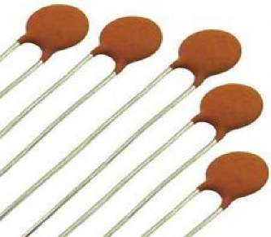
VARIABLE RESISTOR
A variable resistor is a resistor of which the electric resistance value can be adjusted. A variable resistor is in essence an electro-mechanical transducer and normally works by sliding a contact (wiper) over a resistive element. When a variable resistor is used as a potential divider by using 3 terminals it is called a potentiometer. When only two terminals are used, it functions as a variable resistance and is called a rheostat. Electronically controlled variable resistors exist, which can be controlled electronically instead of by mechanical action.
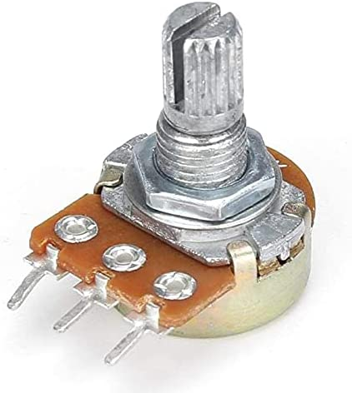
Vero board is a brand of strip board, a pre-formed circuit board material of copper strips on an insulating bonded paper board which was originated and developed in the early 1960s by the electronics department of Vero precision engineering ltd (vape). It was introduced as a general-purpose material for use in constructing electronic circuits - differing from purpose-designed printed circuit boards (pcbs) in that a variety of electronic

circuits may be constructed using a standard wiring board.
the first single-size Vero board product was the forerunner of the numerous types of prototype wiring board which, with worldwide use over five decades, have become known as strip board. Use as with other strip boards, in using Vero board, components are suitably positioned and soldered to the conductors to form the required circuit. Breaks can be made in the tracks, usually around holes, to divide the strips into multiple electrical nodes enabling increased circuit complexity.
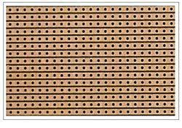
A jumper wire: (also known as jumper, jumper wire, jumper cable, DuPont wire or cable) is an electrical wire, or group of them in a cable, with a connector or pin at each end (or sometimes without them – simply "tinned"), which is normally used to interconnect the components of a breadboard or other prototype or test circuit, internally or with other equipment or components, individual jump wires are fitted by inserting their "end connectors" into the slots provided in a breadboard, the header connector of a circuit board, or a piece of test equipment.

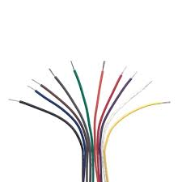
Jumper wires with crocodile
Jump wires at the end of a multi-colored ribbon cable are used to connect the pin header at the left side of a blue usb2serial board to a white breadboard below. Another jumper cable ending in a usb micro male connector mates to the right side of the usb2serial board. Red and black tinned jump wires can be seen on the breadboard.
There are different types of jumper wires. Some have the same type of electrical connector at both ends, while others have different connectors. Some common connectors are:
Solid tips – are used to connect on/with a breadboard or female header connector. The arrangement of the elements and ease of insertion on a breadboard allows increasing the mounting density of both components and jump wires without fear of short-circuits. The jump wires vary in size and colour to distinguish the different working signals.

TDA2822 IC
is one kind of op-amp (operational amplifier) that can be used in low output applications like a stereo amplifier. This IC has some features like it is available in 16-pin power dip package, low crossover distortion, low-quiescent current. The c tda2822 can be worked with a supply voltage of 3v to 15v. The applications of this ic include portable audio systems, preamplifier, hearing aid mini radio, headphone amplifier, etc. The ic tad 2822 can deliver 0.65w of output power. The ic tda2822 can deliver 0.65w o/p power for each channel into a 4-ohm loudspeaker of the 6v supply voltage in the stereo method and 1.35w into a 4-ohm loudspeaker 6v supply voltage in the bridge mode. This article discusses stereo amplifier circuit using tda2822ic in bridge mode, characteristics, and its pcb layout.
Characteristics for tda2822
Voltage supply down to 1.8v
Low intersect distortion
Low inactive current
Stereo or bridge arrangement
Pin configuration of tda2822 ic
The pin configuration of tda2822 ic is shown below.
TDA2822 IC consist of 8-pins such

8
7
6
8
1
2
3
4
Pin1-output pin1
Pin2-vcc
Pin3-output pin2
Pin4-gnd
Pin5-input (-) 2
Pin6-input (+) 2
Pin7- input (+) 1
Pin8-input (-) 1

Pin number | Symbols | Functions
 | Out (1) | 1 channel output
 | Vcc | Power supply
 | Out (2) | 2 channel output
 | Gnd | Ground
 | In –(2) | 2 channel inverting input
 | In +(2) | 2 channel non-inverting input
 | In +(1) | 1 channel non-inverting input
 | In –(1) | 1 channel inverting input

AN ADAPTABLE BOX (also known as a "box") is an enclosure housing electrical connection. Junction boxes protect the electrical connections from the weather, as well as prevent people from accidental electric shocks

Without soldering.
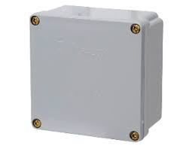
BLUETOOTH
A Bluetooth amplifier is designed to convert your favorite pair of wired headphones into wireless Bluetooth headphones by harnessing the radio frequency communication of Bluetooth technology.

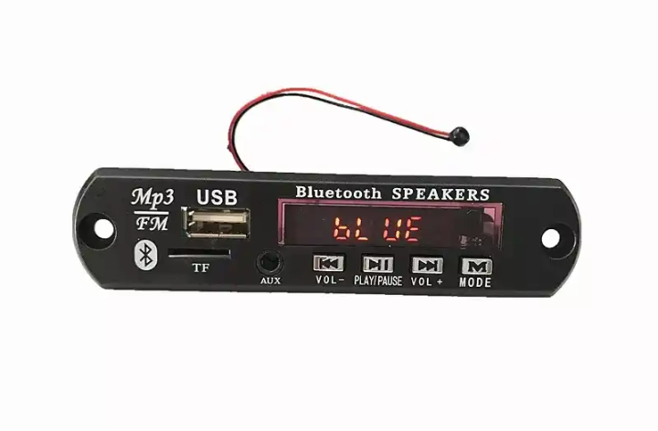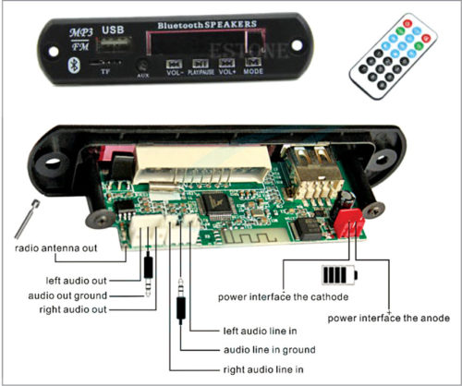
Speakers – there are two speakers of 10-watt power rating and 8 ohms impedance used as load at the output of the operational amplifiers. The speakers are connected at pins 1 and 3 of the ic which are the output pins of the tda2822 and the ground wires of the speakers are connected to the common ground. The 10-watt speakers instead of 6 watts are used as per the availability.
SWITCH
A switch is an electronics device which is capable of switching ON/OFF of an electrical and electronics circuit
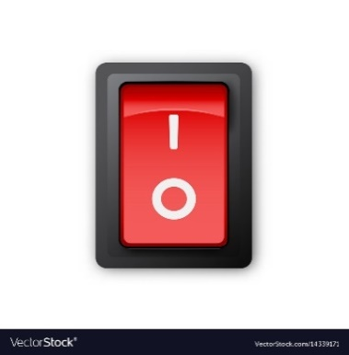
POWER SUPPLY
A POWER SUPPLY is a device that supplies electric power to an electrical load. The term is most
commonly applied to electric power converters that convert one form of electrical energy to another, though it may also refer to devices that convert another form of energy (mechanical, chemical, solar) to electrical energy. A regulated power supply is one that controls the output voltage or current to a specific value; the controlled value is held nearly


3.4 COMPONENT DESCRIPTION
The available component that use in the construction of this project are mentioned in the table below.
Symbols | Component | Rating
Ic | tda2822 | 9-12v
Bt | Bluetooth | 10 meter 30f
Be | Battery | 3.7v
Spk | Speaker | 8Ω
C5 | Ceramic capacitor | 100µf
C6 | Ceramic capacitor | 100µf
R | Variable resistor | 10k
R | Variable resistor | 10k
R | Resistor | 1k

R | Resistor | 1k
R | Resistor | 15k
R | Resistor | 15k
C1 | Capacitor | 220µf
C4 | Capacitor | 10µf
C7 | Capacitor | 10µf
Chg | Charging point | 4.2output – 5v input
Case | Adaptable box | 6-6
Cs | Control switch | On /off
Antenna | Telescopic radio antenna | Medium
Board | Vero board

STEP BY STEP PROCEDURE OF CONSTRUCTION OF AUDIO AMPLIFIER
before making any circuit construction it’s necessary to know the polarity of a component because without knowing the component polarity, a circuit it can’t be constructed and work properly. For instant if you connected a negative terminal of diode instead of positive the supply current would not flow because a diode negative terminal is blocked i.e. It’s can’t allow a flow of current. Here are some of the procedure that i followed when making this construction,
The following precautions must be taken care while assembling the circuit –
1. Always use the filtering capacitor at the input terminal of power supply to avoid the unwanted ripples.
2. Use the speaker of equivalent or high-power rating as amplifier output power.
3. Always use a series capacitor at the output of the amplifier to block any dc component.
4. Always calculate the maximum power rating of the amplifier before connecting it to the speaker. The practical value may differ from theoretical one.
5. Avoid clipping of the output signal as it may damage the speaker.
6. Always place the components as close as possible to reduce the noise in the circuit.
7. Always follow star topology when grounding, this will keep the noise low and reduce the problem of loop grounding.

For generating a stereo sound from two speakers, the tda2822 ic is used. The ic is designed to be used as stereo amplifier or bridge amplifier. Internally it consists of two operational amplifiers. For making stereo amplifier, the circuit connections are done as given in the datasheet of tda2822. The ic can provide a wide range of output power as per the input supply voltage and output load. The power output from the in-built operational amplifiers of the ic has been summarized in the following table –
Fig. 10: table listing power output from in-built operational amplifiers of tda2822 ic
The power output specified in the above table are tested for 1 khz frequency as per the datasheet. As the speakers used at the output have 8 ohms impedance and supply voltage of 9 v is provided to the ic, the typical power output of the opam should be 1 watt. The voltage gain is internally set to be 39 db or 90 which cannot be changed.
The maximum input voltage limit for the ic is fixed so the output power limit cannot be exceeded. On exceeding the power output above 1 watt, the output signal will start clipping. This will add distortion and noise in the output audio. The root mean square (rms) voltage at the output can be calculated by the following equation –
Po = (vrms)2/r
Because when the component gets burnt it can easily be change, or when the component is faulty. It is also important especially in the sub-system, such as the power, oscillator, tone generator, etc. It is easily rectified when it fells to operate or function than when wanted directly on the new board (vero board) which involves soldering of components. Harder and Wilhelm, D. (2014)

CIRCUIT DIAGRAM
Circuit diagram is necessary to be considered from the entire part of the chapter three because it provides a broad and a comprehensive knowledge an also background of the whole project. And it gives detail on the components and their rating before encasement. See the figure bellow:
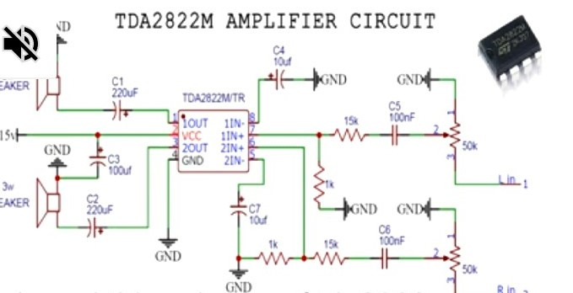
ASSEMBLING OF COMPONENTS
This stage involves mounting of components such as resistors, capacitors, integrated circuit and Bluetooth, speaker, ceramic capacitor, etc. On a vero board for permanent and final connection. When mounting the components, proper care must be taken to ensure that it is mounted in accordance to the circuit diagram. The components are usually mounted by soldering. [10].

SOLDERING
Soldering is defined as the joining of light articles by fusion of alloys which have relatively low melting point. Some components do not require much heat, care must always be taken in order not to burn the components. The materials used in mounting of the components are: soldering iron, solder (tin lead alloy) liquor thinner, brush and Vero board. The greatest danger during soldering is overheating and if the ic exposed to high temperature for a long period it may be damaged. It is also important to use suitable fluxes to avoid deterioration of the leads. [11]

CASE CONSTUCTION
The casing is what houses the entire assembled components in one place. The following materials are largely considered suitable for case construction. These include:
1. Plastic
2. Scriber
3. Steel rule
4. Saw
5. Screw
6. Nails
7. Hammer
The steel rule and scriber are used for taking measurement and marking out lines respectively, drilling machine i also used for drilling holes. Nails were used to tighten the parts together.
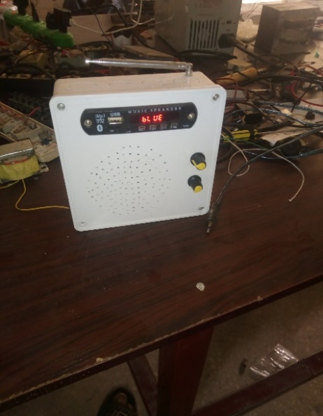
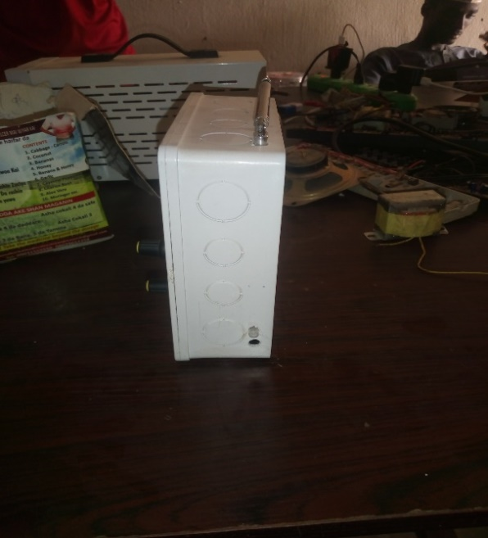
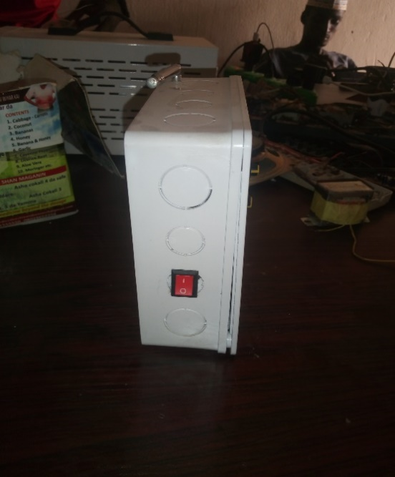
Chapter four
4.0 Testing and evaluation
Testing components is normally carried out by the use of measuring instrument in order to obtain a desired and satisfactory functioning of project construction. This helps to discover the occurrence of fault so as to avoid damage to components. When circuits are designed, it is important to carry out test on breadboard before mounting them permanently on the vero board. In the case of the construction of this solar powered alarm with feedback, all the components used were tested and found to be normal before being mounted on the vero board. However, some of the tests that were carried out on some components are described below;
test procedure
meter test
Bread board test
Circuit test
Meter test
In this project, i decided to use digital multi-meter tester to each component where i obtained the actual value of each component.
Bread board test
After testing the components with the meter (digital multi-meter tester), it was then transferred to the bread board which does not involve soldering of components. It is very important
4.1 resistor test
Resistor, when tested with a meter set at ohm, the pointer / niddle deflects to a reading corresponding to the value of the resistor. This is crosschecked with the color code on the resistor.
4.2 diode test
The testing of diode could be made by the use of ohm meter. To test diode in reversed bias direction, connect the diode across the ohm meter lead set range, switch on a light resistance such as 1kv, 10kv or even mega ohm.
Observation: the diode shows a high resistance.
4.3 capacitor test
The test of the capacitor could be made with ohm meter. With the power disconnected, connect the terminals of the ohm meter across the capacitor terminals.
Observation: the needle swings up scale and return to infinity; the needle moved twice as for upscale and return to the infinity setting.
Precaution:
this is one of the most essential measure that can be greatly enhance the efficiency of the trouble free performance of any appliance and it will help in sustaining the life span of any device for a longer time as it is due some of the precaution to be observed when testing includes:
Do not apply over current or excess current demand for the circuit.
When soldering of component, do not apply excess heat on the component.
4.4 encasement test:
after encasement, the system was tested and was functioning as designed. Finally, the “anti-thief security light” was tested in the workshop under or through the supervision of my able supervisor and was approved [12].
REFERENCES
Bell, A. G. (1880). On the Production and Reproduction of Sound by Light, Third
Series, American Journal of Science, Nature.
Bluegiga (2014). Developing Bluetooth Audio Devices, http://www.bluegiga.
Bosch Security Systems (2012). Wireless Microphone Basics
http://www.electrovoice.com
Boucouvalas, A. C. (1996). Indoor Ambient Light Noise and its Effect on Wireless
Optical Links, IEEE Proc. Optoelectronics, 143(6):334-338.
Carson, M. K.; Bell; A.G: Giving Voice To The World, Sterling Publishing, New
York.
Egan, F.; William. (2003). Practical RF System Design, IEEE Press, Wiley.
Electronic Design (2012). Building Simple Wireless Bluetooth Stereo Audio
Outdoor System.www.electronicdesign.com/communications/build-simple-wireless-
bluetooth-stereo-audio-system-outdoors. Accessed on December 12, 2017.
Franconi, N. G.; Bunger, A.; Sejdic, E. and Mickle, M. (2014). Wireless
Communication in Oil and Gas Wells, Energy Technology, 2(1):996–1005.
Garlington, T.; Babbitt, J.; and Long, G. (2007). Analysis of Free Space Optics
as a Transmission Technology, US Army Information Systems Engineering Command,
[E-book].
German, WWII and WW2 (2011). Lichtsprechgerät 80/80. LAUD Electronic
Design AS.
Harder and Wilhelm, D. (2014). Resistors: A Motor with a Constant Force (Force
Source). Department of Electrical and Computer Engineering: University of Waterloo.
Hranilovic, S. (2005). Wireless Optical Communication Systems. Springer Science
+ Business Media, Inc, Boston.
Manor, H. and Anton, S. (2003). Performance an Optical Wireless
Communication System as a Function of Wavelength, App. Opt., 42(1):4285-4294.
Mohamad, N. R.; Wakiran, A. A.; Iswandi, M. F.; Salleh, Yunus, S. A. M. J.;
Sallehuddin, F.; Azmin, N. F. and Chachuli S. A. M. (2013). Development of
Optical Wireless Audio System using Infrared Light Communications, IOSR journal of
Electronics and Communication Engineering, 8(6):65-69.
REFERENCES
Bell, A. G. (1880). On the Production and Reproduction of Sound by Light, Third
Series, American Journal of Science, Nature.
Bluegiga (2014). Developing Bluetooth Audio Devices, http://www.bluegiga.
Bosch Security Systems (2012). Wireless Microphone Basics
http://www.electrovoice.com
Boucouvalas, A. C. (1996). Indoor Ambient Light Noise and its Effect on Wireless
Optical Links, IEEE Proc. Optoelectronics, 143(6):334-338.
Carson, M. K.; Bell; A.G: Giving Voice To The World, Sterling Publishing, New
York.
Egan, F.; William. (2003). Practical RF System Design, IEEE Press, Wiley.
Electronic Design (2012). Building Simple Wireless Bluetooth Stereo Audio
Outdoor System.www.electronicdesign.com/communications/build-simple-wireless-
bluetooth-stereo-audio-system-outdoors. Accessed on December 12, 2017.
Franconi, N. G.; Bunger, A.; Sejdic, E. and Mickle, M. (2014). Wireless
Communication in Oil and Gas Wells, Energy Technology, 2(1):996–1005.
Garlington, T.; Babbitt, J.; and Long, G. (2007). Analysis of Free Space Optics
as a Transmission Technology, US Army Information Systems Engineering Command,
[E-book].
German, WWII and WW2 (2011). Lichtsprechgerät 80/80. LAUD Electronic
Design AS.
Harder and Wilhelm, D. (2014). Resistors: A Motor with a Constant Force (Force
Source). Department of Electrical and Computer Engineering: University of Waterloo.
Hranilovic, S. (2005). Wireless Optical Communication Systems. Springer Science
+ Business Media, Inc, Boston.
Manor, H. and Anton, S. (2003). Performance an Optical Wireless
Communication System as a Function of Wavelength, App. Opt., 42(1):4285-4294.
Mohamad, N. R.; Wakiran, A. A.; Iswandi, M. F.; Salleh, Yunus, S. A. M. J.;
Sallehuddin, F.; Azmin, N. F. and Chachuli S. A. M. (2013). Development of
Optical Wireless Audio System using Infrared Light Communications, IOSR journal of
Electronics and Communication Engineering, 8(6):65-69.
REFERENCES
[1] Bell, A. G. (1880). On the Production and Reproduction of Sound by Light, Third Series, American Journal of Science, Nature.
[2] Bluegiga (2014). Developing Bluetooth Audio Devices, http://www.bluegiga.
Bosch Security Systems (2012). Wireless Microphone Basics
http://www.electrovoice.com
Boucouvalas, A. C. (1996). Indoor Ambient Light Noise and its Effect on Wireless
Optical Links, IEEE Proc. Optoelectronics, 143(6):334-338.
Carson, M. K.; Bell; A.G: Giving Voice To The World, Sterling Publishing, New
York.
Egan, F.; William. (2003). Practical RF System Design, IEEE Press, Wiley.
Electronic Design (2012). Building Simple Wireless Bluetooth Stereo Audio
Outdoor System.www.electronicdesign.com/communications/build-simple-wireless-
bluetooth-stereo-audio-system-outdoors. Accessed on December 12, 2017.
[3] Bosch Security Systems (2012). Wireless Microphone Basics http://www.electrovoice.com Boucouvalas, A. C. (1996). Indoor Ambient Light Noise and its Effect on Wireless Optical Links, IEEE Proc. Optoelectronics, 143(6):334-338. Carson, M. K.; Bell; A.G: Giving Voice To The World, Sterling Publishing, New York.
[4] Egan, F.; William. (2003). Practical RF System Design, IEEE Press, Wiley.
[5] Electronic Design (2012). Building Simple Wireless Bluetooth Stereo Audio Outdoor System.www.electronicdesign.com/communications/build-simple-wireless-bluetooth-stereo-audio-system-outdoors. Accessed on December 12, 2017.
[6] Franconi, N. G.; Bunger, A.; Sejdic, E. and Mickle, M. (2014). Wireless communication in Oil and Gas Wells, Energy Technology, 2(1):996–1005.
[7] Garlington, T.; Babbitt, J.; and Long, G. (2007). Analysis of Free Space Optics as a Transmission Technology, US Army Information Systems Engineering Command, [E-book].
German, WWII and WW2 (2011). Lichtsprechgerät 80/80. LAUD Electronic
Design AS.
Harder and Wilhelm, D. (2014). Resistors: A Motor with a Constant Force (Force
Source). Department of Electrical and Computer Engineering: University of Waterloo.
Hranilovic, S. (2005). Wireless Optical Communication Systems. Springer Science
+ Business Media, Inc, Boston.
Manor, H. and Anton, S. (2003). Performance an Optical Wireless
Communication System as a Function of Wavelength, App. Opt., 42(1):4285-4294.
Mohamad, N. R.; Wakiran, A. A.; Iswandi, M. F.; Salleh, Yunus, S. A. M. J.;
Sallehuddin, F.; Azmin, N. F. and Chachuli S. A. M. (2013). Development of
Optical Wireless Audio System using Infrared Light Communications, IOSR journal of
Electronics and Communication Engineering, 8(6):65-69.
[8] German, WWII and WW2 (2011).
[9] Lichtsprechgerät 80/80. LAUD Electronic Design AS.
[10] Harder and Wilhelm, D. (2014). Resistors: A Motor with a Constant Force (Force Source). Department of Electrical and Computer Engineering: University of Waterloo.
[11] Hranilovic, S. (2005). Wireless Optical Communication Systems. Springer Science + Business Media, Inc, Boston.Manor, H. and Anton, S. (2003).
[12] Mohamad, N. R.; Wakiran, A. A.; Iswandi, M. F.; Salleh, Yunus, S. A. M. J.; Sallehuddin, F.; Azmin, N. F. and Chachuli S. A. M. (2013). Development of Optical Wireless Audio System using Infrared Light Communications, IOSR journal of Electronics and Communication Engineering, 8(6):65-69.
Bell, A. G. (1880). On the Production and Reproduction of Sound by Light, Third
Series, American Journal of Science, Nature.

